THAMARAI V
192424002

CSA 4705 -DEEP LEARNING
CO2 – Neural Networks and Convolutional Neural Networks

Question 17: Overfitting in Neural Networks
Aim: Training and testing accuracy/error are compared. A large difference between them indicates overfitting.
Google Colab Code and Output:
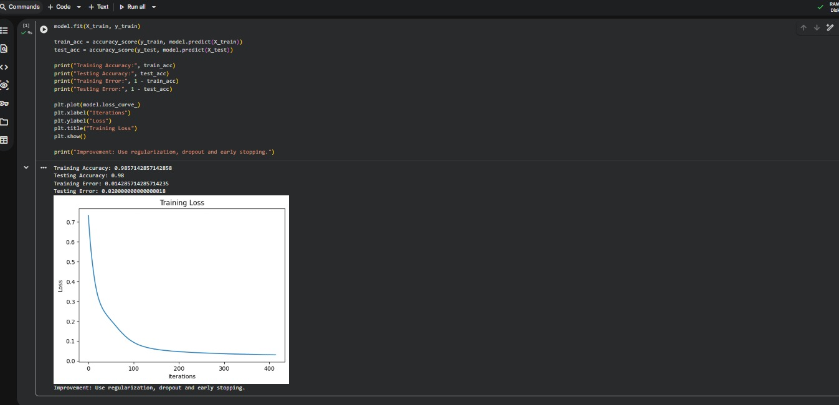
Result: The program was executed in Google Colab. The displayed output is recorded above.

Question 18: Polynomial Regression – Bias–Variance Trade-off
Aim: Polynomial models of different degrees are compared using training and testing mean squared error.
Google Colab Code and Output:
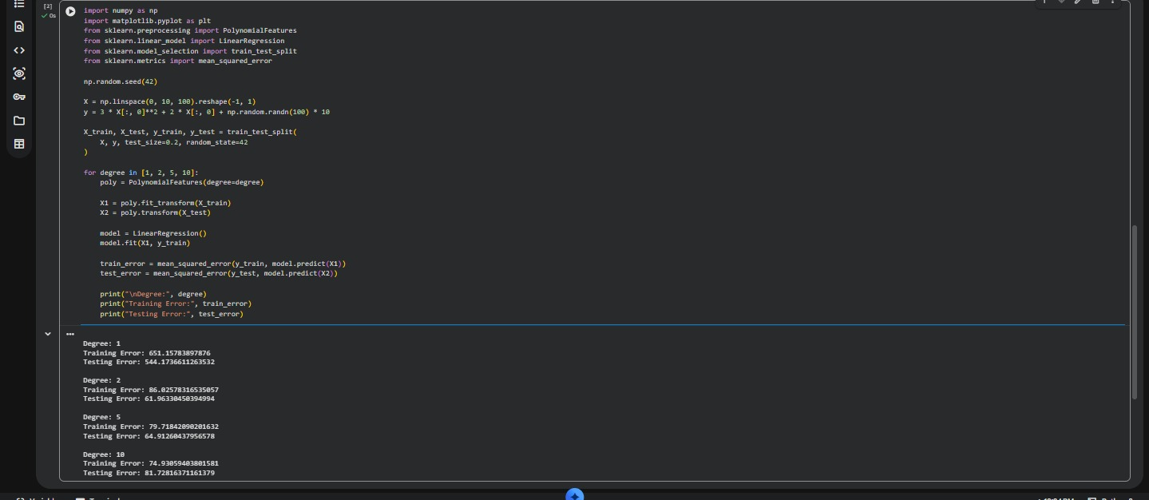
Result: The program was executed in Google Colab. The displayed output is recorded above.

Question 19: L1 and L2 Regularization
Aim: Lasso and Ridge regression coefficients and prediction errors are compared.
Google Colab Code and Output:
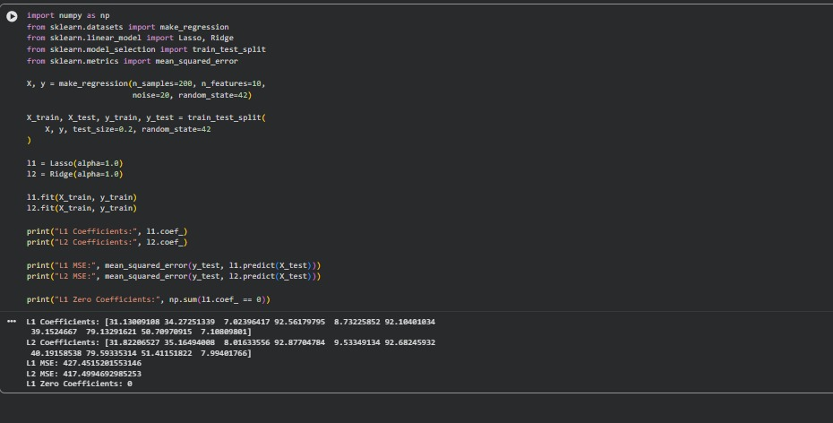
Result: The program was executed in Google Colab. The displayed output is recorded above.

Question 20: Effect of Learning Rate
Aim: Different learning rates are tested and their loss curves are compared to study convergence.
Google Colab Code and Output:
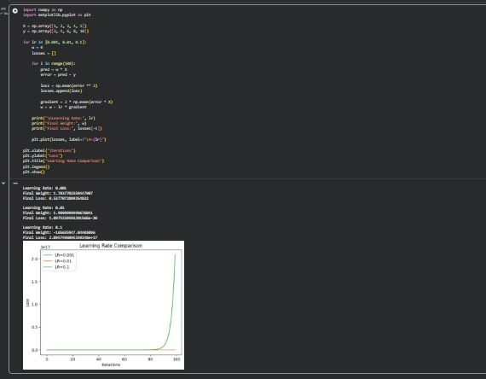
Result: The program was executed in Google Colab. The displayed output is recorded above.

Question 21: Floating-Point Precision Errors
Aim: Float16, float32 and float64 are compared to demonstrate numerical precision differences.
Google Colab Code and Output:
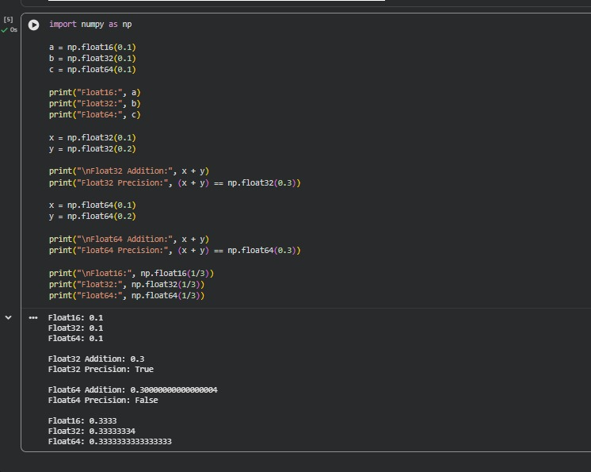
Result: The program was executed in Google Colab. The displayed output is recorded above.

Question 22: Hyperparameter Optimization
Aim: Grid search, random search and Bayesian optimization are compared using a classification dataset.
Google Colab Code and Output:
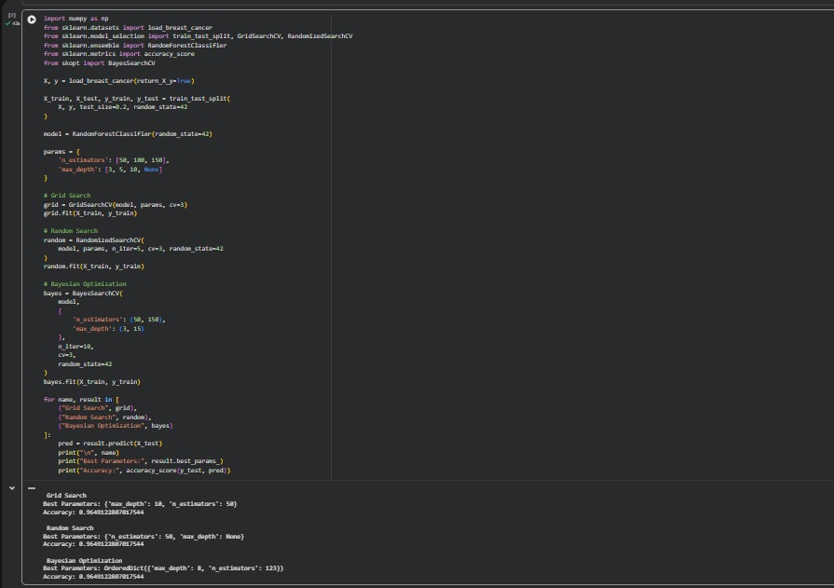
Result: The program was executed in Google Colab. The displayed output is recorded above.

Question 23: Reinforcement Learning – Traffic Signal Control
Aim: A Q-learning agent selects traffic signal actions using states and reward feedback in a simulated environment.
Google Colab Code and Output:
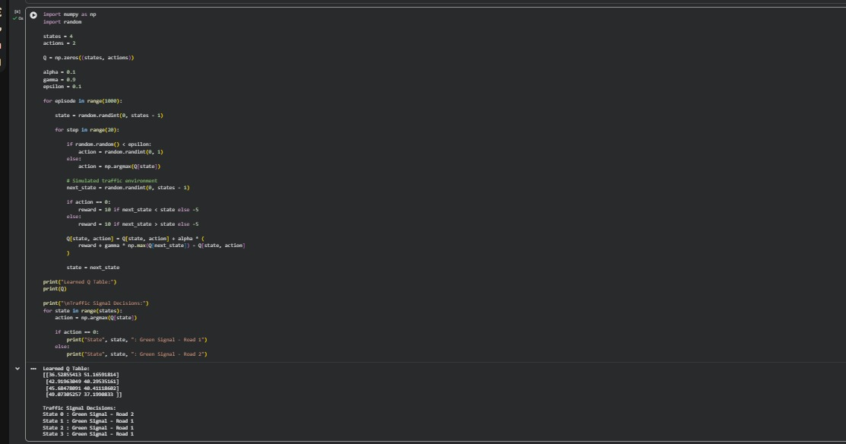
Result: The program was executed in Google Colab. The displayed output is recorded above.

Question 24: Single-Layer Perceptron
Aim: A perceptron classifies a loan applicant as eligible or ineligible using income and credit score.
Google Colab Code and Output:
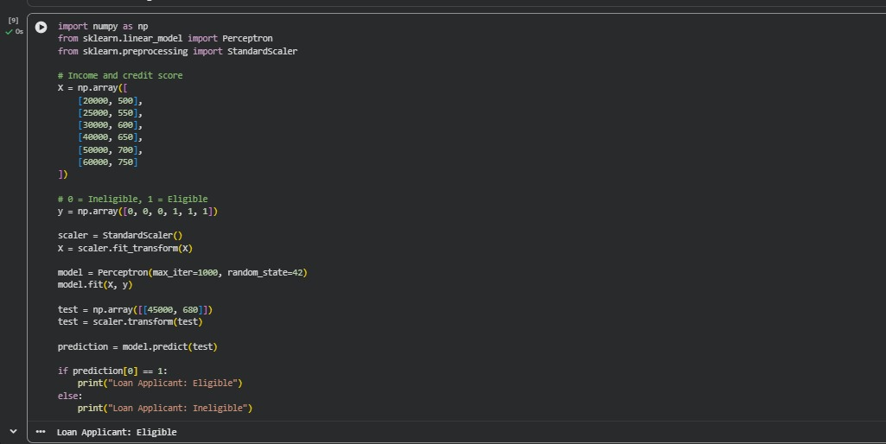
Result: The program was executed in Google Colab. The displayed output is recorded above.

Question 25: XOR Using a Feedforward Neural Network
Aim: A neural network with a hidden layer learns the XOR input-output pattern.
Google Colab Code and Output:
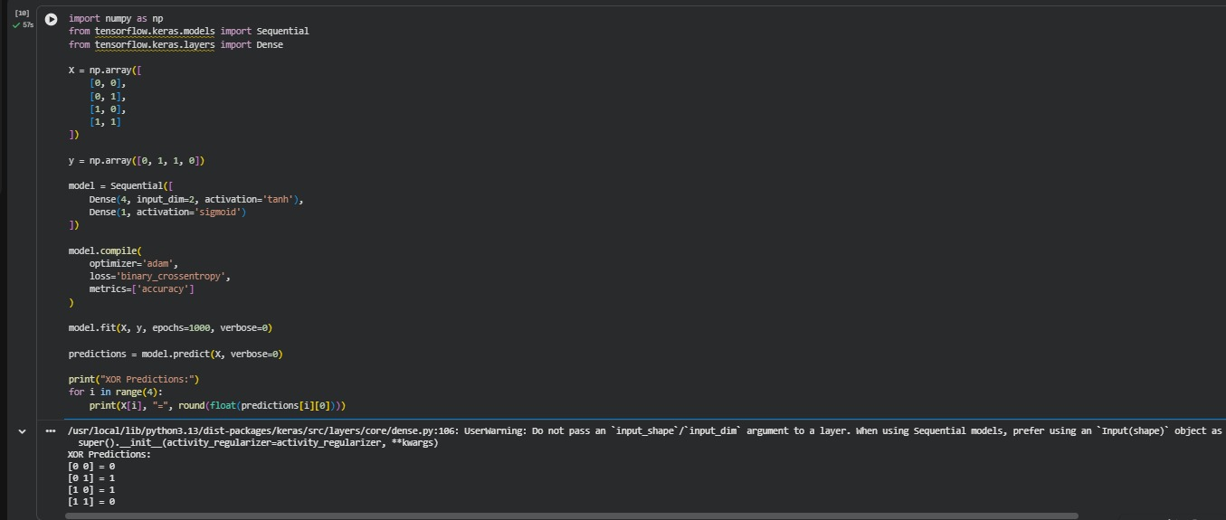
Result: The program was executed in Google Colab. The displayed output is recorded above.

Question 27: Activation Functions – Sigmoid, Tanh and ReLU
Aim: The output curves of sigmoid, tanh and ReLU activation functions are visualized and compared.
Google Colab Code and Output:
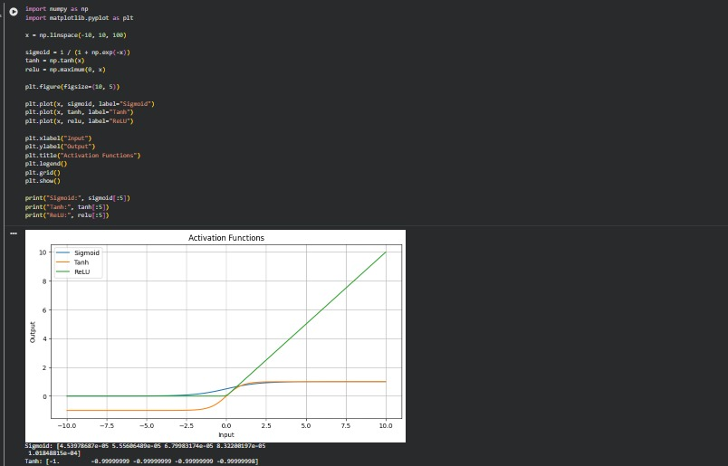
Result: The program was executed in Google Colab. The displayed output is recorded above.

Question 28: Comparison of Activation Functions
Aim: Separate neural networks are trained using ReLU, sigmoid and tanh and their test performance is compared.
Google Colab Code and Output:
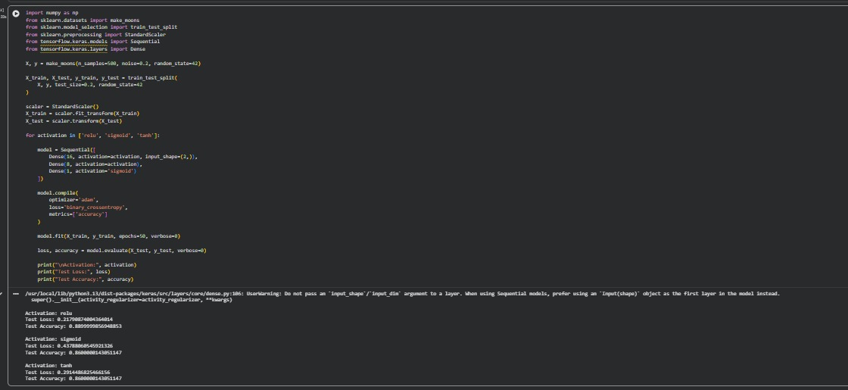
Result: The program was executed in Google Colab. The displayed output is recorded above.

Question 29: Forward Propagation in a Neural Network
Aim: Hidden-layer and output-layer values are calculated using weights, biases and sigmoid activation.
Google Colab Code and Output:
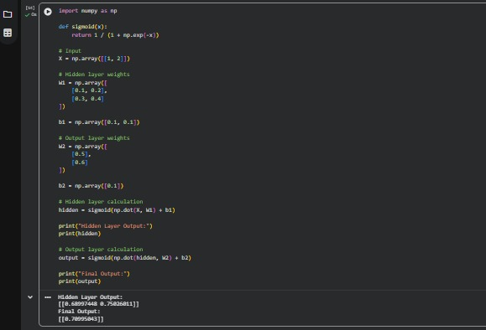
Result: The program was executed in Google Colab. The displayed output is recorded above.

Question 31: House Price Prediction Using Neural Network
Aim: A neural network predicts house prices using mean squared error and compares actual and predicted values.
Google Colab Code and Output:
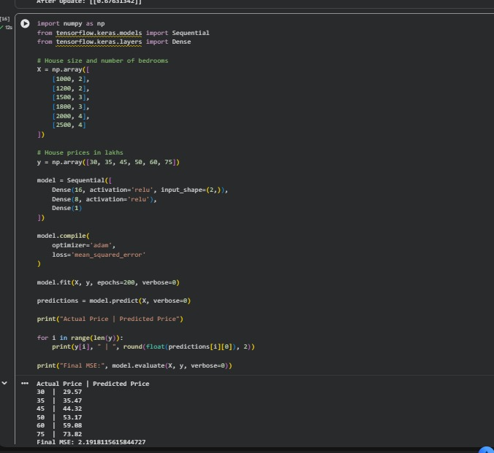
Result: The program was executed in Google Colab. The displayed output is recorded above.

Question 32: Fraud Detection Using Binary Cross-Entropy
Aim: A binary classification neural network predicts fraudulent and legitimate transactions and calculates binary cross-entropy loss.
Google Colab Code and Output:
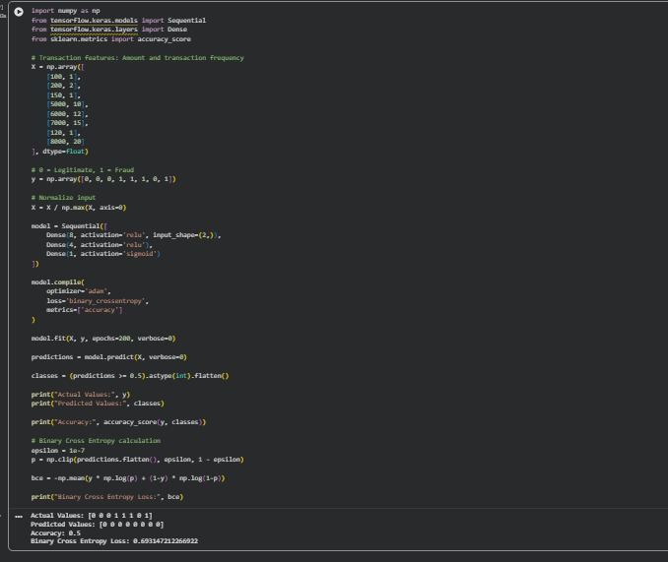
Result: The program was executed in Google Colab. The displayed output is recorded above.

Question 26: Iris Flower Classification Using a Multilayer Neural Network
Aim: The Iris dataset is used to classify flowers into three species. The output screenshot was not included in the uploaded batch.
Screenshot status: Not received. This section can be completed when the corresponding Google Colab screenshot is provided.

Question 30: Backpropagation Algorithm
Aim: Gradients are calculated and network weights are updated to reduce prediction error. The output screenshot was not included in the uploaded batch.
Screenshot status: Not received. This section can be completed when the corresponding Google Colab screenshot is provided.

